Suniy intellekt asoslari fanidan 2-topshiriq
1-masala. Fayl nomi o'zgartirish: os.rename() yordamida oldfile.txt faylllini newfile.txt ga nomi o'zgartiring.
import os
old_name = "oldfile.txt"
new_name = "newfile.txt"
# Fayl nomini o'zgartirish
try:
os.rename(old_name, new_name)
print(f"Fayl muvaffaqiyatli o'zgartirildi: {old_name} → {new_name}")
except FileNotFoundError:
print(f"Xatolik: '{old_name}' fayli topilmadi.")
except Exception as e:
print("Xatolik yuz berdi:", e)
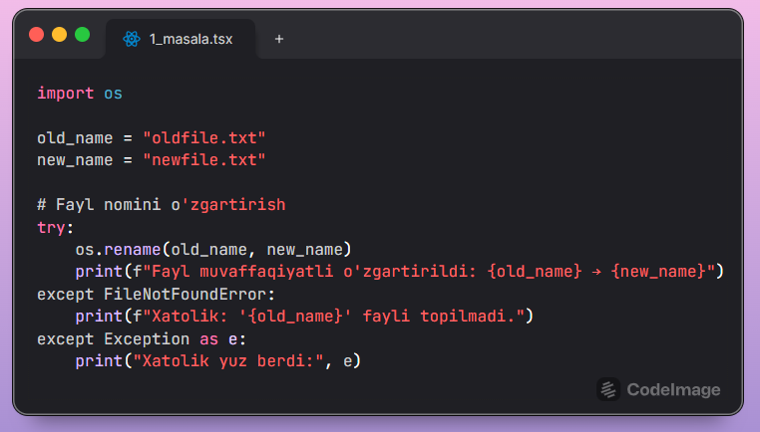

2-masala. Faylni o'chirish. os.remove() yordamida oldfile.txt faylini o'chirib tashlang.
import os
file_name = "oldfile.txt"
try:
os.remove(file_name)
print(f"Fayl muvaffaqiyatli o'chirildi: {file_name}")
except FileNotFoundError:
print(f"Xatolik: '{file_name}' fayli topilmadi.")
except PermissionError:
print(f"Xatolik: '{file_name}' faylini o‘chirishga ruxsat yo‘q.")
except Exception as e:
print("Xatolik yuz berdi:", e)
